Year 10 Science (Adjusted)
Semester 1 Examination 2020 - Revision

Earth and Space Sciences

1. Complete the following table.

TERM | DEFINITION
light year
constellation
galaxy
nebula
supernova
red giant
black hole
fusion

2. Light travels at 300,000 km/second. A star is 97.6 light years away. We can only travel at about 15 - 20 km/second with our best rockets. No calculations are necessary.

(a) With our current technology, are we likely to be able to travel to this star in the near future? Give a few reasons for your answer.

YES / NO (Circle your answer.)

Reasons: •

•

•

(b) Suggest one way we might be able to overcome the time factor of travelling to other galaxies, given it could be hundreds of years.

3. (a) What is the major element found in the Sun?

(b) What happens to this element so that the Sun produces its energy?
(HINT: Think about the fusion process.)

(c) The Sun loses 5 million tonnes of mass per second. According to Einstein's equation (E = mc²), what does this mass become?

4. How is the surface temperature of a star related to its colour?

TEMPERATURE | COLOUR
 | blue
 | red
 | yellow

5. (a) About how old is our Sun (in millions of years)? million years

(b) How much longer will it "live"? million years

6. Use the following words to complete the following flow diagrams.

white dwarf black dwarf nova supernova red giant

black hole red supergiant neutron star

(a) Draw a flow diagram (with arrows) to show the stages of our Sun's remaining life as it runs out of fuel.

Sun

(b) Do similar flow diagrams for the following types of stars.

Huge star

Giant star

7. Give two characteristics of a black hole.

•

•

8. The diagram below shows the spectra (black lines) seen on the light coming from distant galaxies. Look at the "double lines" shown here. This shows the lines as seen in our laboratory.

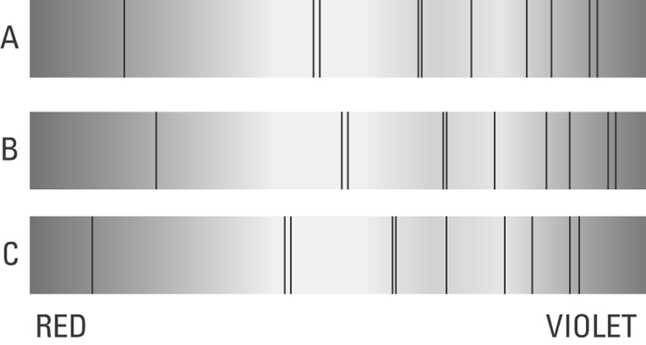

Look at B and C above and where the double lines have moved.

(a) Circle the lines that have been "red-shifted". (1)

(b) Does "red-shift" mean the galaxy is moving towards us? Circle your answer.

YES NO (1)
9. Below is a list of the four spheres on Earth. Give a brief description of each.
i.e. What do you find in each one?

Biosphere:

Atmosphere:

Hydrosphere:

Lithosphere:

10. Describe two consequences of global warming.

•

•

11. The following diagram shows the rock cycle and the water cycle. Complete the diagram with appropriate labels.

12. (a) Label the diagram below showing the water cycle. Us the following words.

evaporation infiltration precipitation runoff

transpiration condensation

13. The following diagram shows the carbon cycle. Label the processes missing from the diagram using the words below.

combustion photosynthesis respiration

14. Use the words in the following to complete the sentences.

Human Biology

1. (a) What are the male and female gametes in animals called?

(b) What are the genotypes (actual genes) for a male and a female?

2. DNA is thought to be a twisted ladder structure called a double helix. There are a series of bases located between the two strands of the helix.

(a) Name the four bases.

G A T C

(b) Which bases are paired together?

3. Define the following terms.

allele
pure-bred
hybrid
homozygous
heterozygous
genotype
phenotype
sex-linked
dominant
recessive
co-dominant
incomplete dominance
haploid
gene

4. Below is a diagram showing the mitosis cell division process. The stages are in the wrong order. Try to put them in the correct order in the blank diagram.

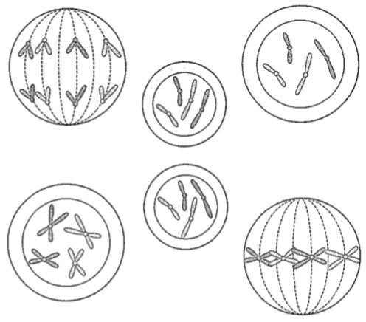

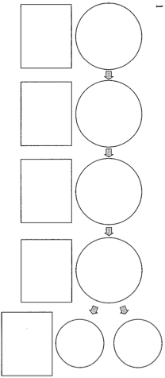

5. Polled cattle do not have horns. This is a dominant phenotype arising from the action of a gene P. Horned cattle are therefore pp hybrids.

What are the offspring of a hybrid polled bull (Pp) crossed with a pure-bred horned cow (pp)? Show full working.

6. The following pedigree shows the occurrence of no ear lobes in a family. It is a dominant trait.

i.e. E = no ear lobes e = ear lobes

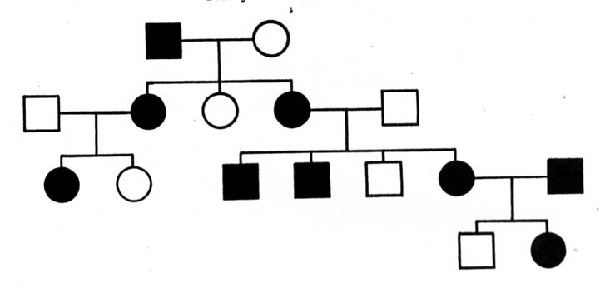

(a) How many males have no ear lobes?

(b) How many females have lobes?

(c) What is the genotype for an individual with lobes?

7. (a) How many chromosomes are found in a human skin cell (a normal cell)?

(b) How many chromosomes are found in the reproductive cells?

(c) Name the process used to make reproductive cells? m

8. (a) Who determines the sex of a child - the mother or father? Explain why.

(b) A family has had five boys born into it, and the mother is pregnant with a sixth child. What is the chance that the child will be a girl?

